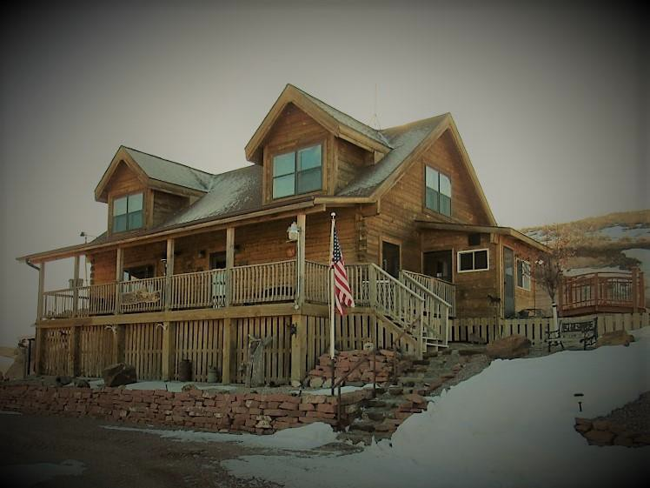
75 S. SLIM BUTTES RD * CHADRON, NE
Jessica Brueckner 308-430-4094 Donny Grantham 308-430-4678
Take in the stunning views from the spacious deck of this custom-built Heritage home located just 3 miles outside of Chadron. This 4 bedroom, 1 ¾ bathroom home features an open concept layout with vaulted ceilings and an additional loft area perfect for enjoying the views of this 62-acre property. Every detail of the home has been meticulously crafted to compliment the theme and style of the home and gives you the vacation cabin feel year-round. The beautifully landscaped property boasts a sizeable barn with four 10x10 stalls with turnout pens and a tack room, as well as a 28x80 shop with a heated workroom and concrete floors. Covered storage on each side of the shop offers additional storage and shelter for vehicles, machinery, and hay. Outbuildings have electricity and frost-free hydrants. Call today to schedule a showing!

List Price $425,000
www.WesternViewRealEstate.com

Jessica Brueckner * Broker Associate Western View Real Estate
308-432-6828 Day or Night 308-430-4094
All information has been provided by sources deemed reliable, however accuracy is not guaranteed.
Prospective buyers are responsible to verify all information to their satisfaction. Offering is subject to approval of purchase by owner, prior sale, price change, correction or withdrawal without notice.

Additional Information
- Heritage Log Home
- 6x12 Solid Milled Logs with dovetail ends
  - Custom Hickory kitchen cabinetry
  - Instant hot water heater in kitchen
    - Stainless Steel Appliances
  - Pellet Stove for supplemental heat
    - Main floor laundry
- Master Suite with double vanity, shower, soaking tub
  - Private Balcony
- Lennox Heating and Cooling System
  - Water Softener
- Mudroom with utility sink
  - Bonus Family Room
- 2 double car carports
- Attached single car garage
- Fully covered deck with panoramic views
- Fully fenced with several separate grazing units
- Additional covered storage for horse trailer or RV
  - Red Rock access road
- 22-acre field currently utilized for grass hay
  - Private well and Septic
    - Underground power
- 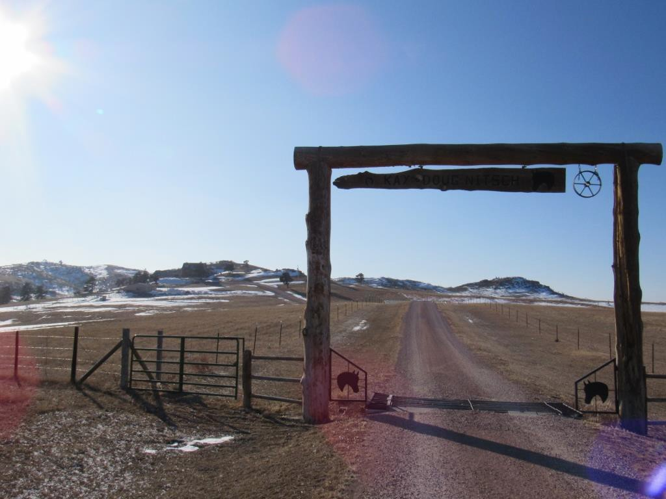Located close to USFS and State wildlife management areas

